

Software Design Document

Ryan Evans
Barry Chapman
Sam Williams
Devin Coger
SoftEng06
www.radford.edu/~softeng06
10/20/2009
Revisions
Version | Primary Author(s) | Description of Version | Date Completed
11/11/09 | Team Shock Force | All sections being filled. | 11/11/09

Review & Approval
Requirements Document Approval History
Approving Party | Version Approved | Signature | Date
Devin Coger
Dr. T. L. Lewis

Requirements Document Review History
Reviewer | Version Reviewed | Signature | Date
Barry Chapman
Ryan Evans
Samuel Williams

Contents
1 Introduction 1
1.1 System Overview 1
1.2 Supporting Materials 1
1.3 Definitions and Acronyms 1
2 Functional Requirements Mapping Overview 2
3 High Level Design 8
3.1 Conceptual View (Architectural Context Model) 8
4 Low Level Design 10
4.1 Process Model 10
5 User Interface Design 14
5.1 Application Control 14
5.2 Screen 1..n 14

Introduction

System Overview
We are developing a system to enable the administrator or other employees to seamlessly enter data about an auction item (min bid, price, name, etc.) in to an Access form to hasten their bidder’s checkout time. Such information will be stored in the database. Developed in Access, our system will work with Excel to import and export data efficiently to the end user in order to facilitate the problem of long wait times between bidders. The system is going to be developed with multiple employees as the end user. So, knowledge of Access falls solely on the employees after brief training of both Access and the software applied to it. There will be sufficient security applied to the database, based on the sensitivity level of the information encapsulated.
The customer and the user for the system are the employees of the IDANRV, including Mrs. Sheila Roop, and the developers of the system are the Shock Force Software Team.

Supporting Materials
Microsoft Visio was used to develop the conceptual model and the process model.
Microsoft Office was used to develop this particular document.

Definitions and Acronyms
IDANRV- Intellectual Disabilities Agency of the New River Valley

Functional Requirements Mapping Overview

Functional Requirement | Design Artifact
1:Items provided to the IDANRV shall be stored in Access Database | <Figure 1>: 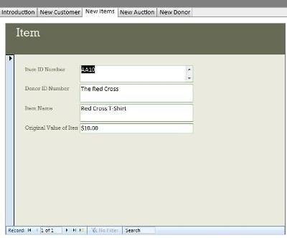
2: The items shall be accessible via queries and reports | <Figure2>: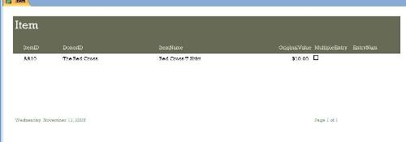
3.1: The data stored be able to be manipulated through forms. | 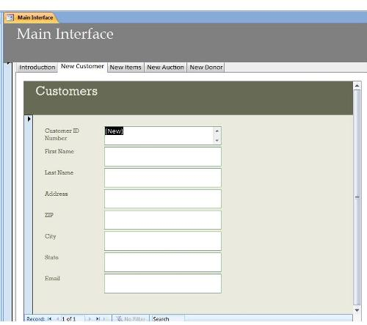  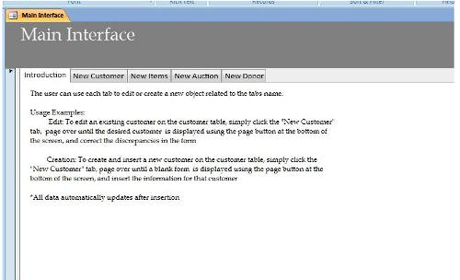  3.2  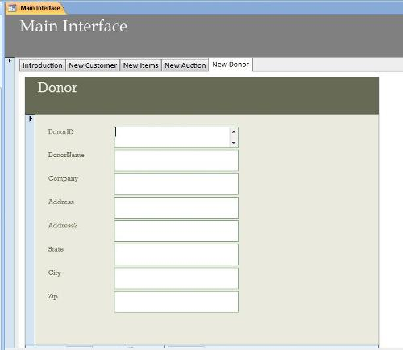  3.3
4. The auctions shall be recorded into the database via forms | <Figure4> 1: 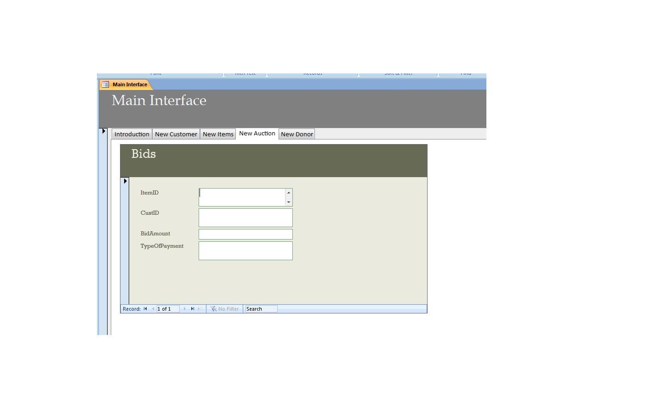
5: Users will be able to modify and add users. | <Figure5>:
5. The user will easily use the database due to given instructions. | <Figure 6>

High Level Design

Conceptual View (Architectural Context Model)
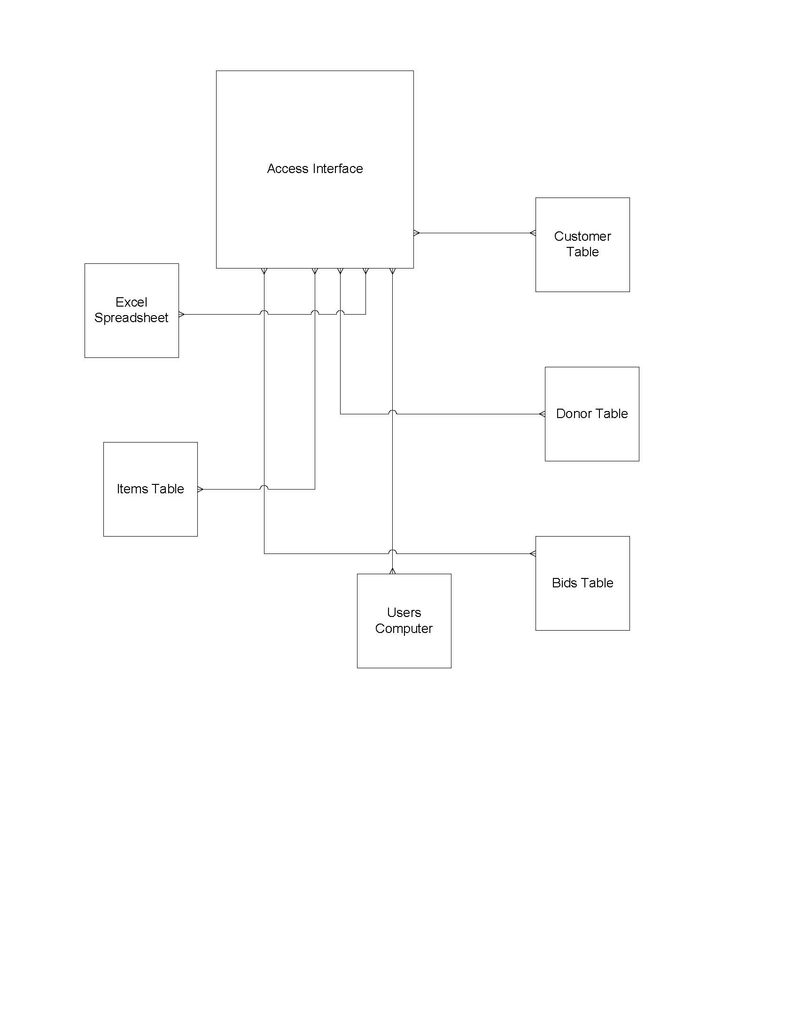

Low Level Design

Process Model
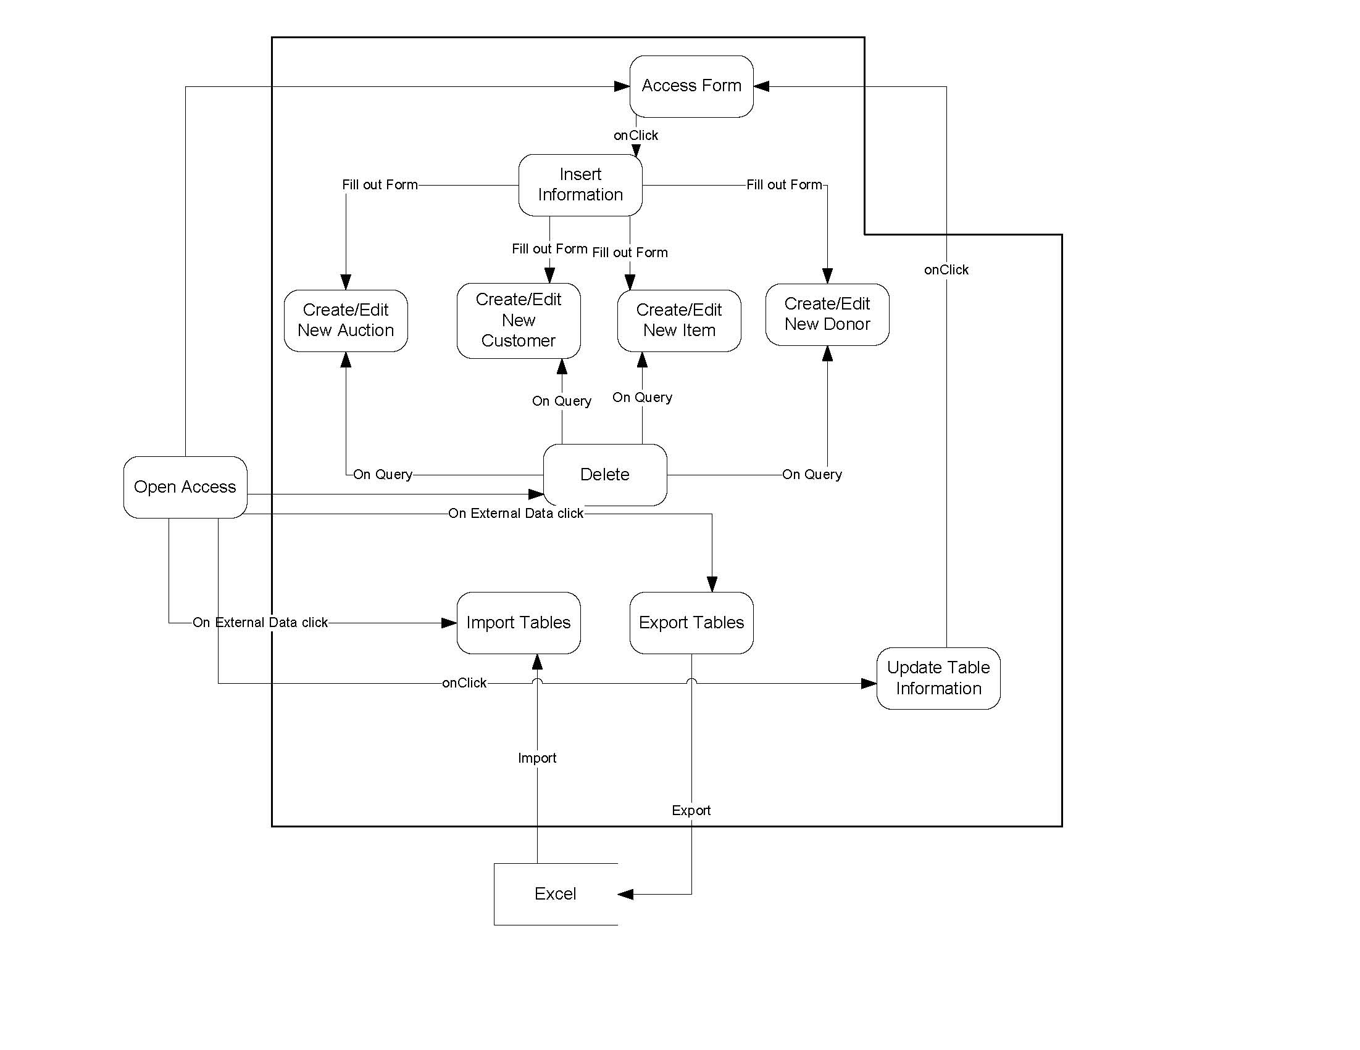
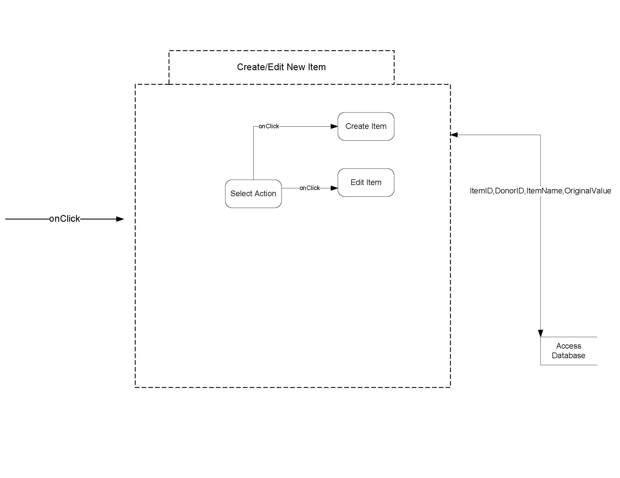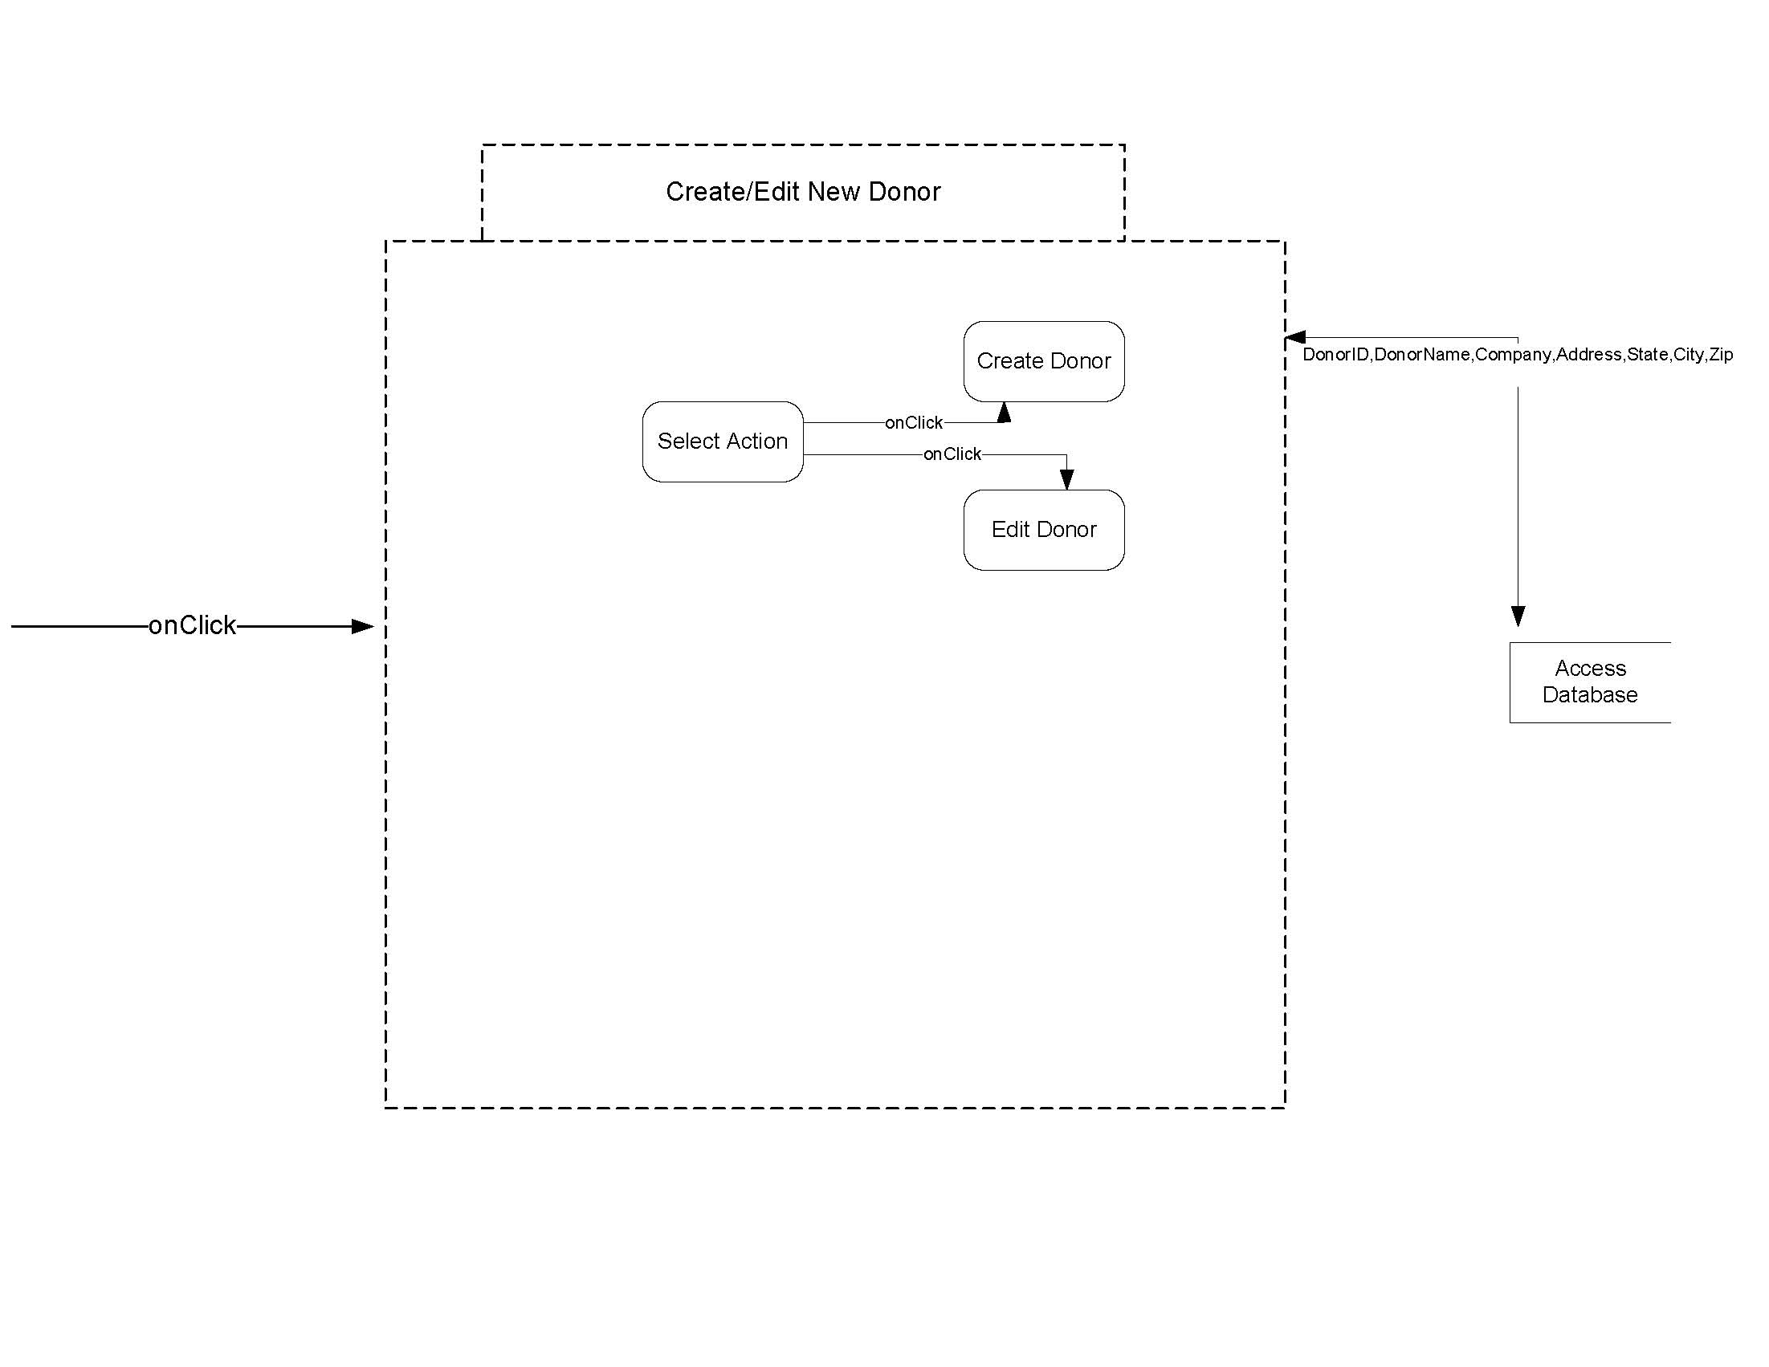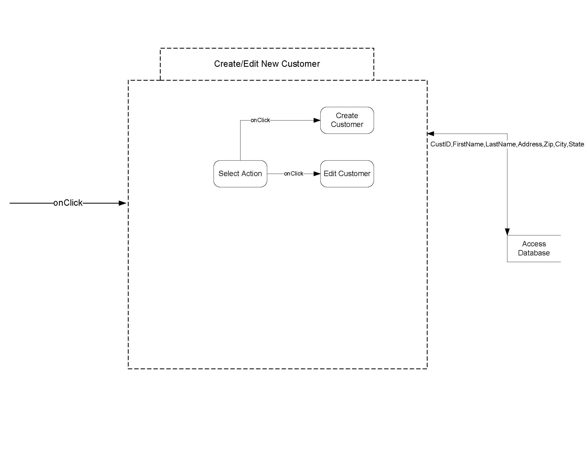

User Interface Design

Application Control
All user interface screens will be related to the insertion of data or data reporting. The forms, screens used for data creation and data update, are controlled by the user through tabs. The tabs allow the user to move in between different types of objects (e.g. Customers, Items, etc...). The look and color of the database interface is completely controlled by Access, because the database uses the default Access interface created by Microsoft. The forms, on the other hand, were created by our software team. Each encompasses a gray header and five tabs of each object type. The forms are pictured below for better interface analysis.

Screen 1..n
The main interface includes five tabs, including a series of forms used to insert information:
5.2.1“Introduction” Tab - This tab is the default tab that is displayed first. It holds the instructions on how to navigate throughout the main interface [It does not affect the database in any way]:
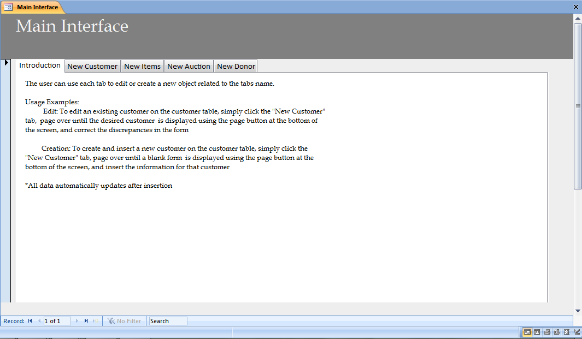

5.2.2“Customer” Tab – This tab holds the form for editing an existing customer and creating a new customer, by inserting information into the form [This changes the information on the database immediately]:
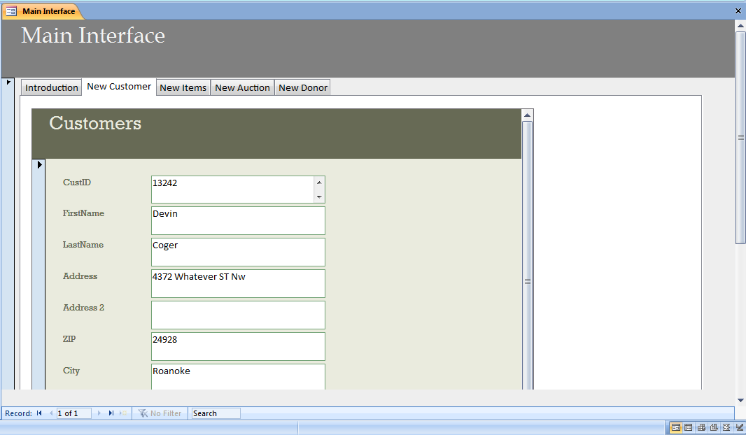
5.2.3“Item” Tab – This tab holds the form for editing an existing item and creating a new item, by inserting the information into the form [This changes the information on the database immediately]: (next page)
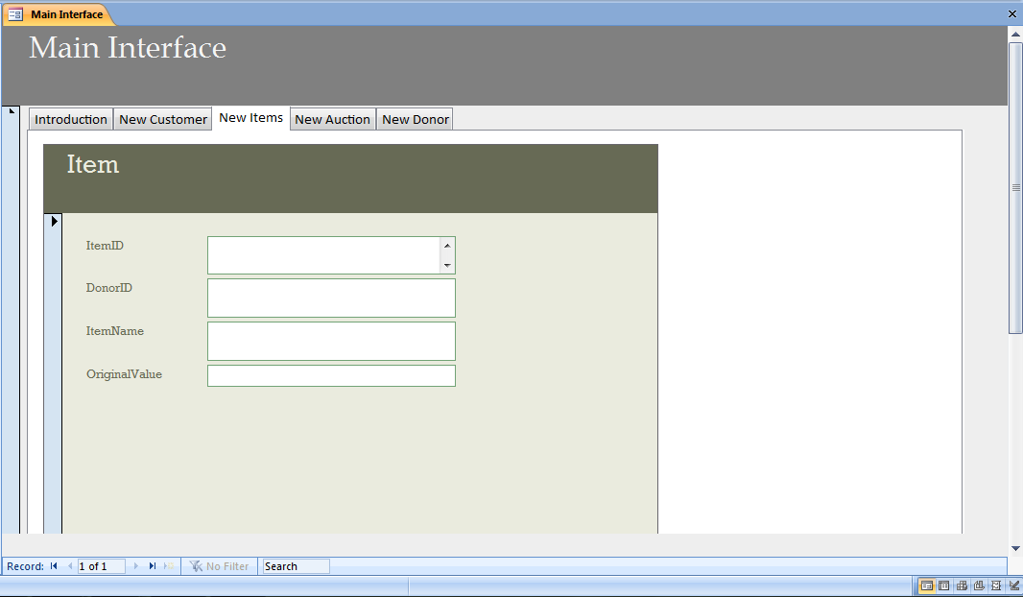
5.2.4“Auction” tab – This tab hold the form for editing an existing auction and creating a new auction, by inserting the information into the form [This changes the information on the database immediately]:
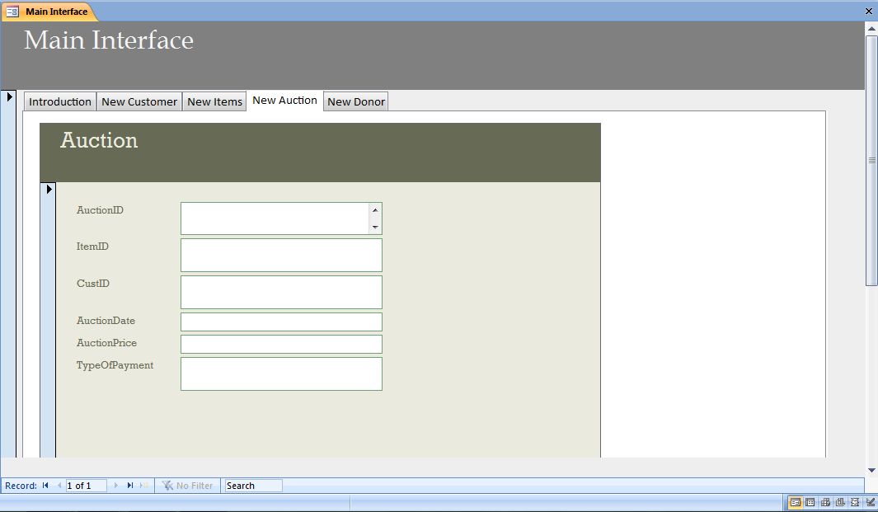

5.2.5“Donor” tab – This tab hold the form for editing an existing donor and creating a new donor, by inserting the information into the form [This changes the information on the database immediately]:
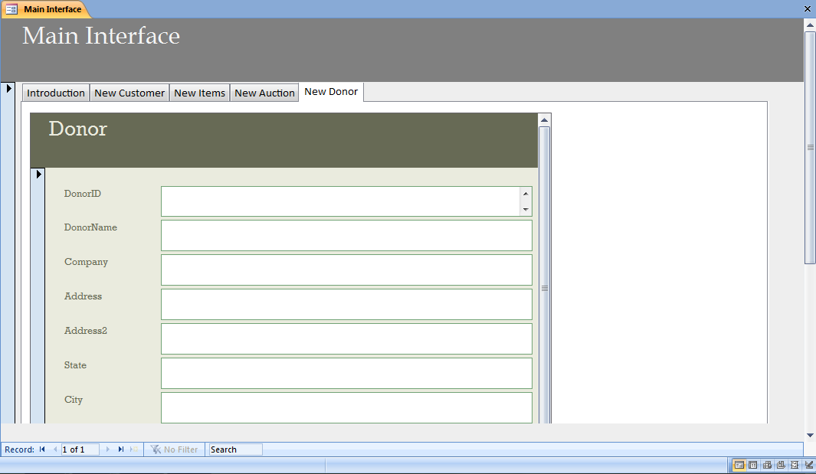
5.2.6 “Database Screen” - The database itself can be found in the Access interface: [This is the Customers table for example – information on screen is just for reference and debugging purposes – subject to change*]:


